Counting Crime: Examining changes in crime reporting under the NIBRS standard in City of Seattle

DS522: Data Acquisition and Analytics

City University of Seattle

Rosalia Miray - [mirayrosalia@cityuniversity.edu](mailto:mirayrosalia@cityuniversity.edu)

Matthew Thibault - [thibaultmatthew@cityuniversity.edu](mailto:thibaultmatthew@cityuniversity.edu)

Jeremy Grub - [grubjeremy@cityuniversity.edu](mailto:grubjeremy@cityuniversity.edu)

**Abstract**

Since 1930 the FBI has maintained records of crime across the country under their Uniform Crime Reporting (UCR) Program. In the 93 years since data collection began the FBI has utilized two separate systems of record keeping. The original standard was the Summary Reporting System (SRS) while the second, which began collecting data in 1989, is the National Incident-Based Reporting System (NIBRS). For more than 30 years from 1989 to the end of 2020 both standards were maintained by the FBI for crime reporting. This project aims to examine changes in crime statistics reporting based on switching from the SRS standard to the NIBRS standard. Looking at crime statistics in the City of Seattle for the years from 2016 to 2020, it was found that the older SRS method underreported the amounts of offenses in broad categories ranging from motor vehicle theft to sex offenses. The cause of these findings is the Hierarchy Rule that the SRS method utilized when recording incidents. While the highest severity crimes, homicides, were unaffected, all other categories of offenses recorded were affected to varying degrees.

**Keywords**: Crime, NIBRS, SRS, Statistics, Python, NumPy, MatPlotLib, Seaborn

**1.** **INTRODUCTION**

This project aims to examine any changes in crime statistics that can be correlated to the National Incident-Based Reporting System (NIBRS) standard implementation. Prior to the NIBRS standard implementation, the Summary Reporting System (SRS) standard was the most common standard and only reported on the most serious crime in each incident. Additionally, while the SRS had a limited set of categories that crimes would be grouped into and did not record other relevant data points for crime analysis, the NIBRS records a large amount of additional data about each crime such as age, ethnicity, and gender of offenders and victims, weapons used, location of incident, responding precinct and more.

Our project intends to study the methodology of NIBRS and SRS as well as utilize exploratory data analysis via the python modules Pandas and NumPy. Our primary target is to identify if the number of offenses, both in total and per offense type, have changed as a direct consequence of reporting methodology. Additionally, we will attempt to identify which categories of offenses are most affected by the reporting change and propose possible explanations for why they are affected to such a degree. Lastly, we will utilize seaborn and matplotlib to develop visualizations of any insights discovered.

**2. LITERATURE REVIEW**

The SRS and the NIBRS are subprograms within the larger Uniform Crime Reporting (UCR) program. The UCR itself has its origins in the 1920’s when it was recognized that there was a need for national crime reporting. It was at this time that the International Association of the Chiefs of Police (IACP) formed the Committee on Uniform Crime Records to develop a system of recordkeeping for crime statistics (National Incident-Based Reporting System, 2015). In order to achieve their objective, the committee began to study existing state practices for recordkeeping as well as their criminal codes. The result was a plan that, among other things, standardized the definitions for seven main offense classification known as Part I crimes and ultimately became the foundation of the UCR. (NIBRS, 2015). It was also at this time that the Hierarchy Rule was established as part of the crime reporting procedure which would become the basis for the SRS.

In January of 1930 the first cities began to participate in the UCR program, these cities represented 20 million inhabitants in 43 states (NIBRS, 2015). Over the years the number of participating jurisdictions would continue to grow. By 2015 over 97% of the total population of the United States was represented by the crime data collected by the UCR program. The crime data provided by the UCR is used extensively by professionals in many fields including criminology, sociology, psychology, municipal planning, and more. This data is freely available to the public and made easily accessible through the Crime Data Explorer (CDE) tool that the FBI administers on their website.

The UCR program today has the same primary goal as it had at its inception: to generate accurate information for use in law enforcement administration, operation, and management (NIBRS, 2015). The program is comprised of three subprograms with one now defunct subprogram. The three active subprograms are the NIBRS, Law Enforcement Officers Killed and Assaulted (LEOKA), and the Hate Crimes Statistics Program. The inactive subprogram is the SRS which was discontinued in January of 2021. This study focuses exclusively on the SRS and the NIBRS programs.

**Summary Reporting System**

The SRS was established in 1930 as part of the UCR program as a universal crime reporting system that could collect nationwide data about crime. The purpose of this subprogram was to make it possible to track crime trends throughout the country and make the statistics available to the public. Before the establishment of the SRS, recordkeeping for crimes varied considerably from state to state and made the objective of creating national statistics on crime a daunting task.

As part of creating this system, the UCR studied the recordkeeping practices in the states and identified seven major offense classifications as well as a Hierarchy Rule. The rule established the reporting procedure of only reporting the highest level of crime for any incident in which multiple crimes were committed. For instance, if the crimes of homicide and aggravated assault occurred over the course of the same incident, only the crime of homicide would be recorded as it is the higher of the two crimes. The seven original crime classifications are subdivided into violent crimes and property crimes. The four violent crime classifications in order of most severe to least severe are as follows: homicide, rape, robbery, and aggravated assault. The three property crime classifications in order of most severe to least are: burglary, larceny/theft, and motor vehicle theft. In 1979 arson was added as a Part I property offense, however unlike the other offenses it does not follow the Hierarchy Rule, rather it is recorded in addition to any of the other offenses. Due to this arson will be omitted from the scope of this study. As a final note, violent crimes take precedence over property crimes.

The SRS served its purpose for over 50 years until the 1980s when it became clear that a more robust system of crime reporting was needed to better understand the many variations in the major crime categories as well as the multitude of circumstances that crime takes place. Although an alternative reporting system (the NIBRS) was established during the late 1980s the SRS would continue to see use by many jurisdictions throughout the nation for several more decades. The shift away from the SRS was slow going. The two major complaints that jurisdictions had for making the shift were a lack of finances needed to adopt the change and concern that the differences in reporting procedure would make crime rates appear to rise.

However, in the mid 2010’s it was recommended by the Criminal Justice Information Services (CJIS) Advisory Policy Board that the FBI transition to a NIBRS-only data collection system. By October 31, 2020, 43 states had NIBRS certification and 8742 law enforcement agencies representing 48.9% of the national population were reporting NIBRS data (Criminal Justice Information Services Division, 2020). Then, on January 1, 2021 the SRS was officially retired.

**National Incident-Based Reporting System**

The NIBRS is the National Incident-Based Reporting System and was developed by the FBI to upgrade the Uniform Crime Reporting program or UCR. While its predecessor, the SRS, was used to capture summary of data, the NIBRS captures data on an incident level and aims to understand the individual incidents as well as the victims, offenders and offenses, and property involved in each incident. The level of detail then provides a deeper insight into multiple different aspects of each incident. Utilizing NIBRS allows for a broader range of offense categories compared to the narrower categories of the SRS. NIBRS pays more attention to the already recognized categories of offenses like murder, rape, robbery, and aggravated assault but also to drug offenses, fraud and vandalism. NIBRS captures additional contextual information such as the relationships between victims and offenders, the locations, and times of incidents as well as any weapons used. This kind of contextual information allows for law enforcement to have more detailed and standardized crime data as well as facilitate better comparisons and allocate resources more effectively. The FBI is specifically aiming to streamline the way crime is reported nationwide to provide more useful statistics and better inform policing.

The process of ending the use of the SRS began in the 1980s when the FBI outlined a few areas of enhancement needed for the UCR program to meet informational needs. The agencies would need to use an incident-based system to report offenses and arrests. Later, the UCR program would launch a quality assurance program. When first moving the UCR to the NIBRS data the UCR looked at redesigning within policy, definitions, offense codes, data elements and data values within their system. One benefit of this system is the ability to be flexible over time. There have been many different additions to the information captured within an incident to include a variety of crimes including bias motivated, gang activity, law enforcement assaulted or killed, cargo theft and offender ethnicity. The flexibility the program allows also made possible location and property types to be even more specific.

**3. METHODOLOGY**

For this analysis there are two major concerns that need to be addressed. Firstly, the two reporting systems have very different recording methodologies. Whereas the newer NIBRS is focused on gathering incident specific data to better understand the nuances for each incident, which includes recording up to 10 offenses per incident, the SRS only categorized each incident as a single offense. This means that for SRS data, for each year and area, only aggregate data for broad categories such as homicide or theft exist. For example, crime statistics for Seattle (as a whole) in the year 1996 consist of just 8 data points which correspond to the total number of homicides, rapes, aggravated assaults, robberies, nonresidential burglaries, residential burglaries, thefts, and vehicle thefts. This means that to compare SRS and NIBRS data, much of the additional information captured by the NIBRS system must be dropped and only aggregate crime statistics can be looked at. The NIBRS offenses that correspond to earlier SRS classifications are depicted in Figure 1.

**Figure 1:** NIBRS offense categories used to calculate SRS equivalent. According to the Criminal Justice Services Division (2012). SRS offenses are also listed in descending order of severity according to the Hierarchy Rule.

The second major concern is acquiring data for both the SRS and NIBRS methodologies over the same time period as this would mean that reporting agencies would have to put in the time and effort to report the same incidents twice. In the end this was not an option, as one might expect there was little incentive to spend the extra resources. The result is that for the city of Seattle, freely available SRS data exists from 1996 up to 2007, and from 2008 to present there is only NIBRS data. To address this issue this project has had to compile SRS equivalent data using NIBRS sources for the years being compared.

**4. PREPARATION AND RESULTS**

The first step was to gather the datasets from the NIBRS for Washington state for the 2020 year. The NIBRS tracks which department responds to each incident, since the focus of this study is on Seattle, only incidents reported by the Seattle Police Department were considered. The NIBRS also recognizes many offenses that are beyond the scope of this analysis and so these offenses were trimmed out of the dataset. This was done using the NIBRS offense codes which are unique identifiers for each kind of offense. Next, the data was organized by offense type and aggregated using the major categories of the SRS methodology. For example, the NIBRS distinguishes between pocket-picking and purse-snatching but for the SRS these are both considered theft. At this point the NIBRS aggregate data points are fully compiled.

To create the SRS equivalent data, we applied the hierarchy rule for each incident that had multiple offenses. For each incident only the offense with the highest priority was kept, all other offenses were dropped. SRS aggregates were then compiled from the new set of offenses. The totals for both SRS and NIBRS offenses are shown in Figure 2.

We can see that high level offenses saw little or no change as a percentage of total offenses regardless of reporting methodology. On the other hand, motor vehicle theft, the lowest level offense tracked, saw the greatest change.

The total number of offenses reported using the NIBRS system was 1626 higher than the equivalent SRS report or a total increase of about 3.32%. The percent increase for switching from the SRS reporting method to the NIBRS reporting method for each offense category was calculated using formula (1) where TN is the total NIBRS statistic, and TS is the total SRS statistic.

(TN – TS) / TS x 100 (1)

The results of which are shown in Figure 3. As expected, homicide offense reporting remained unchanged since homicide is regarded as the most severe offense category. Each of the other offence categories were affected to varying degrees by the switch in methodologies with motor vehicle theft seeing the greatest change by a wide margin.

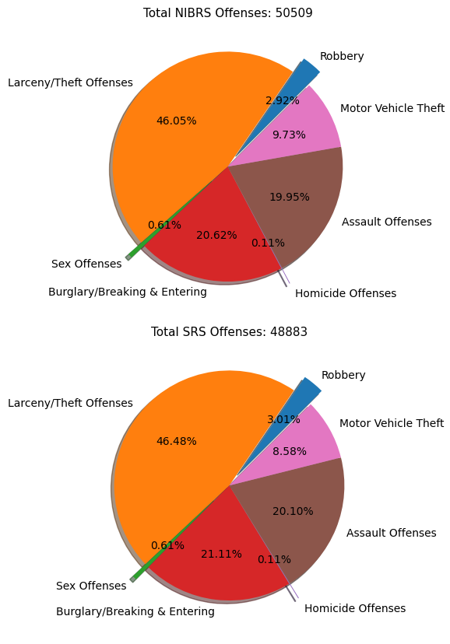 **Figure 2:** Breakdown of totals of offense types for the NIBRS reporting methodology and the SRS reporting methodology as reported by the Seattle Police Department in 2020.

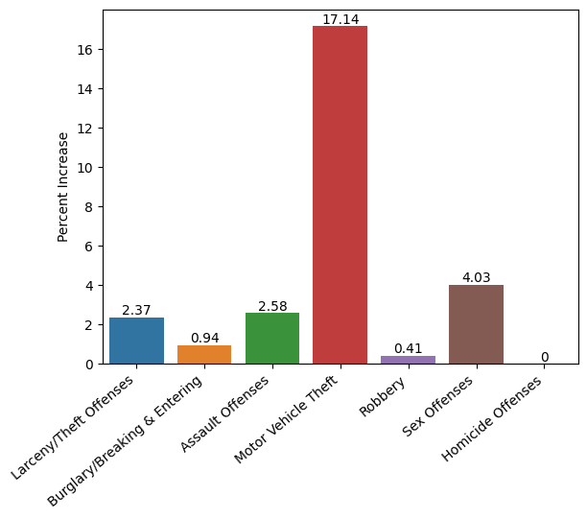**Figure 3:** Change in number of offenses reported for switching from SRS to NIBRS as reported by the Seattle Police Department in 2020.

This is likely due to the fact that motor vehicle theft is regarded as the lowest severity offense category and was there for overridden by all other offenses.

Another point to make is the connection between the sex offenses and homicide offenses. After motor vehicle theft, sex offenses saw the greatest increase in reporting. This is a noteworthy point because sex offenses are considered to be the second highest in terms of severity. Only incidents involving some form of homicide can result in sex offenses going unreported under the SRS methodology. Therefor it can be concluded that the roughly 4 percent apparent increase in sex offenses reported were incidents in which a death also occurred.

**Years 2016 to 2019** The process detailed above was repeated for each year from 2016 to 2019 giving a total of 5 years analyzed. The results of each of these analyses are much the same as for 2020 with 1 notable exception. While motor vehicle theft is consistently the most underreported offense by percent change in the SRS methodology, the degree to which it is underreported for 2016 to 2019 is significantly lower than the 2020 figures suggesting that the 2020 statistic is an outlier. Additionally, the connection between homicide offenses and sex offenses appears to be reinforced with the additional analyses as sex offense are consistently the second or third most underreported offense using the SRS methodology. The results of all 5 years are summarized in Figure 4. Note that homicide offenses have been omitted as they are always 0 percent.

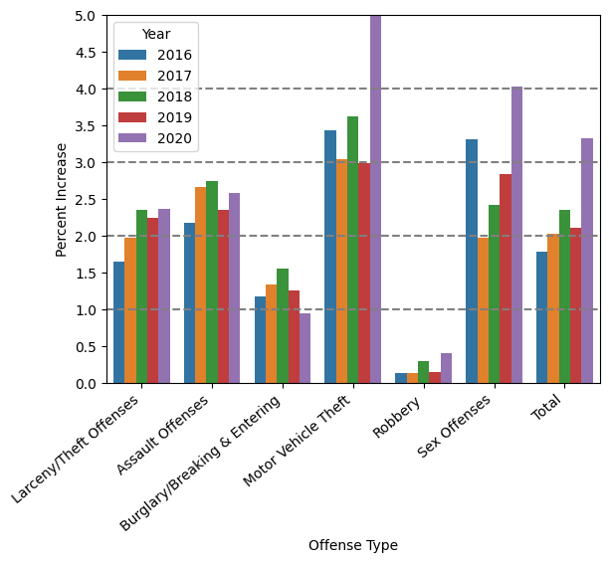 **Figure 4:** Change in number of offenses reported for switching from SRS to NIBRS as reported by the Seattle Police Department for the years 2016 to 2020. Note that Motor Vehicle Theft for the year 2020 is an outlier, its value is 17.14%.

**5. CONCLUSION**

While the actual number of offenses have not changed, this project has shown that the switch from the SRS reporting methodology to the NIBRS reporting methodology has given the impression that offenses have risen. This is due to the Hierarchy Rule that the SRS used when recording incidents in which multiple offenses were committed. With the Hierarchy Rule, only the highest severity offense is recorded, while the NIBRS methodology allows up to 10 offenses to be recorded. All Part I offense types in the SRS have shown some increase after the switch to NIBRS with the exception of homicide offenses which are the highest severity according to the hierarchy rule and therefore were always reported under the SRS methodology. Additionally, it was found that the lowest severity offense, motor vehicle theft was the most affected by the change in reporting methodology and that surprisingly the second most affected category was sex offenses, which includes the offenses of rape and sexual assault with an object. Given that sex offenses are considered quite severe it is proposed by this study that the incidents in which the sex offense was dropped in SRS reporting must have also had a homicide offense, suggesting that to some degree sex offenses and homicide offenses tend to be coincident.

**6. WORKLOAD ASSIGNMENTS**

Rosalia Miray:

-Wrote abstract

-Wrote Introduction section

-Contributed to the datasets and references

-PowerPoint editing and vocal recording

Matthew Thibault:

-Wrote Literature Review and SRS sections

-Contributed to the datasets and references

-Primary data analysis

-Wrote Methodology, Results, and Conclusion

Jeremy Grub:

-Wrote the NIBRS section

-Reviewed and edited the paper

-Made the PowerPoint

**7. REFERENCES**

Criminal Justice Information Services Division (CJIS). (2012, July). *Conversion of National Incident Based Reporting System (NIBRS) Data to Summary Reporting System (SRS) Data*. U.S. Department of Justice, Federal Bureau of Investigation.

<https://www.dps.arkansas.gov/wp-content/uploads/2020/05/Conversion-of-NIBRS-Data-to-SRS.pdf>

Criminal Justice Information Services Division (CJIS). (2020, November). *UCR Focuses on NIBRS and Other Tools to Make More Relevant Data Available to Users*. U.S. Department of Justice, Federal Bureau of Investigation. <https://ucr.fbi.gov/nibrs/2019>

National Incident-Based Reporting System (NIBRS). (2015). *About the Uniform Crime Reporting (UCR) Program*. U.S. Department of Justice, Federal Bureau of Investigation.

<https://ucr.fbi.gov/nibrs/2015/resource-pages/aboutucrmain_final.pdf>

National Incident Based Reporting System (NIBRS). (2020). *Crime Incident-Based Data by State*. [Data Set]. Crime Data Explorer, Federal Bureau of Investigation.

<https://cde.ucr.cjis.gov/LATEST/webapp/#/pages/downloads>

National Incident Based Reporting System (NIBRS). (2022). *Additional Datasets, Summary Reporting System (SRS)*. [Data Set]. Crime Data Explorer, Federal Bureau of Investigation.

<https://cde.ucr.cjis.gov/LATEST/webapp/#/pages/downloads>

Seattle Police Department (SPD). (2023). *SPD Crime Data 2008–Present*. [Data Set]. Seattle Open Data.

<https://data.seattle.gov/Public-Safety/SPD-Crime-Data-2008-Present/tazs-3rd5>